**TE Flickering Solution Proposal v1**

**Background**

SK9822a light strands are experiencing flicker when LED CLK is driven at 2MHz on 500 strand runs. The flicker appears to be most pronounced around 15%-50% brightness levels. Flicker begins to be visible at roughly 2/3’s of the way down the 500 pixel strand, with the flicker getting progressively worse until the end of the strand. Driving CLK at 1MHz alleviates this issue, however, TE 72fps frame rate targets require 2MHz CLK.

**Root Cause Summary**

The root cause is that our 5V rails are not stable near the LEDs. Tests on single 50 LED runs show +-1V swings towards the end of LED strands, even when clocking at 1MHz. The LEDs seem to be tolerant to these swings at 1MHz but cannot tolerate 2MHz. Our Meanwell power supplies are functioning as expected and are not contributing to this issue.

**Proposed Solution**

-Stabilize the 5V rails by adding capacitors as close to the LED strands as possible. Our tests show that optimal sites for this are at unused 2 pin power injection sites and at end of strand 4 pin termination points.

-Capacitor assemblies should be made with two ends, one male and one female. This will give us versatility to deploy in:

-Stub configuration (open power site -> Capacitor Assembly -> NC)

-Serial configuration (data/power in -> Capacitor Assembly -> data/power out)

Recommended configurations we should order (see figure below) :

2 Prong Female -> Capacitor PCB -> 2 Prong Male

4 Prong Female -> Capacitor PCB -> 4 Prong Male

Populate with one 470uF Automotive Grade Electrolytic Capacitor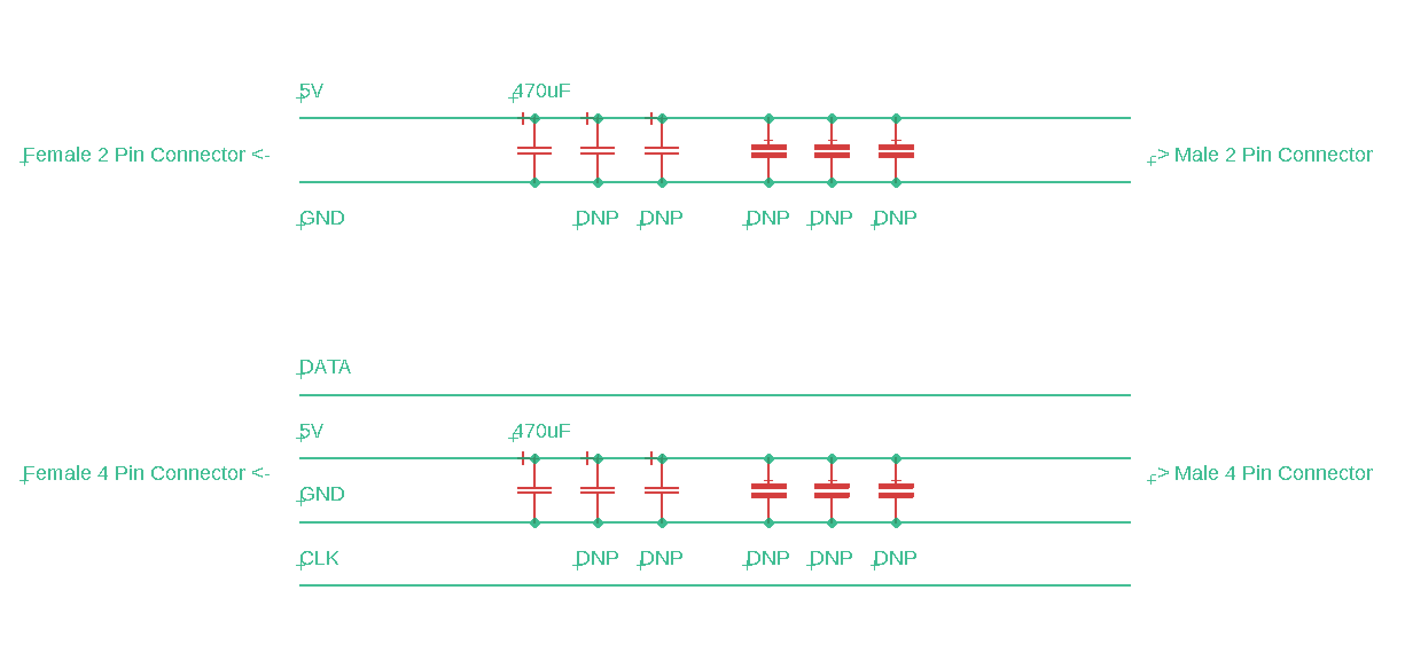

**Risks**

-Changes in power source and grounding from SVN mains power compared to TE generator power can change the stability of this fix.

-Higher/lower ambient air temperature will cause different LED and capacitor performance. It is possible that a ‘fix’ in our test conditions will not perform across all temp ranges

-Added vibration from vehicle motion, speaker system, etc may add unexpected line instability. Overspec’ing the amount of sites we add capacitors should help with this.

**Mitigation**

We should expect Playa conditions to be much different than our test setups, therefore we should make these as versatile as possible. We can do this by:

-Ordering a few variations of capacitor values (1000uF, 470uF and Shiji Design Rec)

-Ordering some that allow us to fill unpopulated capacitor positions to allow us to add additional caps if needed